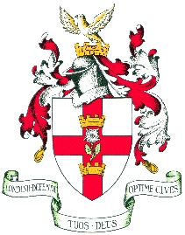
The Guild of Freemen of the City of London

Patron
THE RIGHT HONOURABLE THE LORD MAYOR

The Clerk
Rooms 78/79
65 London Wall
London, EC2M 5TU
Tel: 020 7239 9016
email: clerk@guild-freemen-london.co.uk
Registered Address
4 DOWGATE HILL, LONDON EC4R 2SH
Company Number
00109150
A Company Limited by Guarantee

6th September 2024

Dear Members,

I hope you have enjoyed your Summers, despite the changing weather.

Before the break the Master and Guild Members took to the streets of the City once more to enjoy a guided walk led by Peter Tomkins, Past Master Wax Chandler. We are ever so grateful to him for sharing his knowledge, this time of the Livery Halls, and safely leading our group to their final destination, The Rising Sun Pub, where a dinner was very welcome!

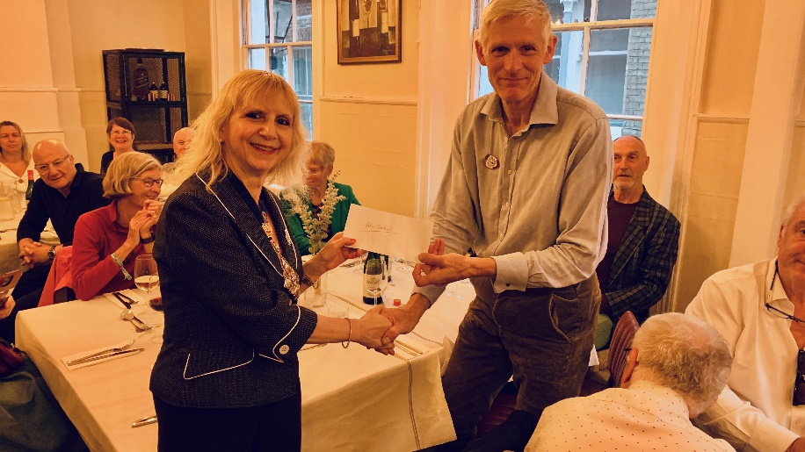
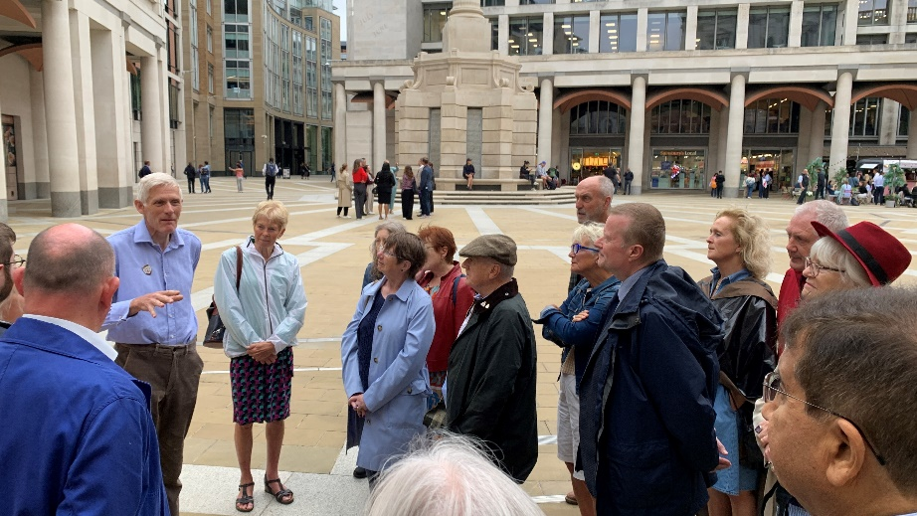

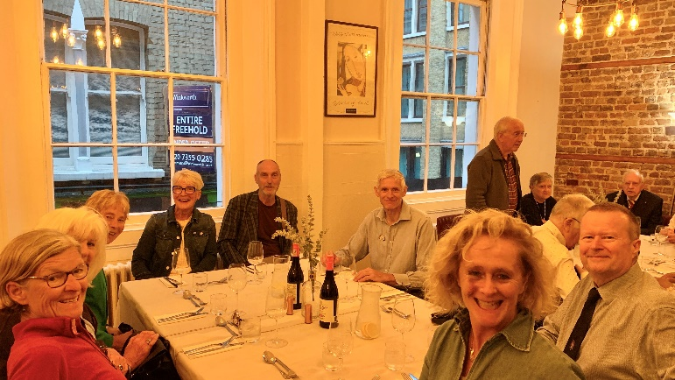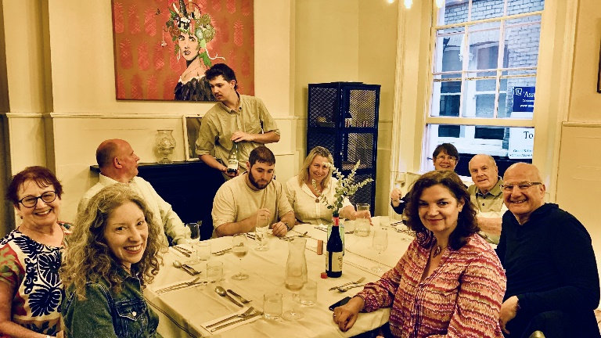

The City Walk was the final event before the Master’s trip to Cyprus, and what a trip it proved to be!

The Hotel and the views from the rooms were wonderful, with excellent service, and for a significant number of the group, the stroll to the sea and dip therein was a welcome relief after daytime temperatures of 30-36 degrees! Many of us had not visited Cyprus before and our guide Antonia was a mine of information, and the itinerary was full.

On Friday we visited the Island’s capital Nicosia (Lefkosia) where we visited the Greek Orthodox Cathedral of St John (no photos allowed) before heading off to the Cyprus Museum which houses a large collection of objects and artifacts from the 9th millennium BC to the early Byzantine period. I especially liked the vase below, where you can see where some more modern artists (Picasso) acquired their inspiration, though the symbol like a swastika is a bit disconcerting……

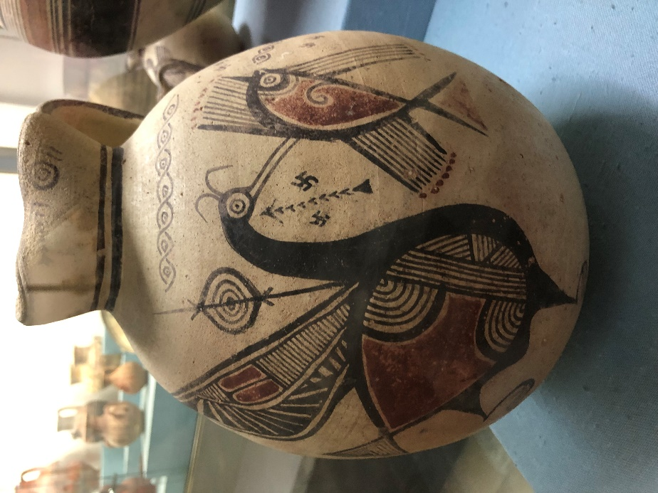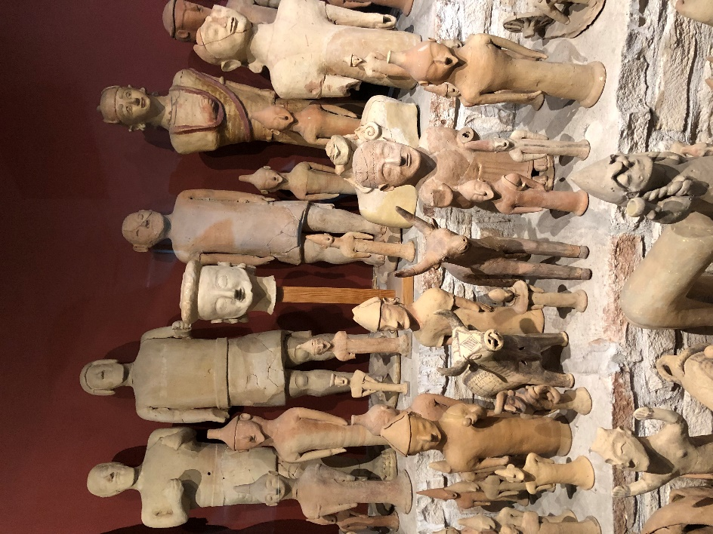

Due to the Master’s heritage and contacts we were privileged to visit the Presidential Palace (built when the English administered Cyprus) and where the Master presented His Excellency President Nikos Christodoulides with a pair of Guild cufflinks.
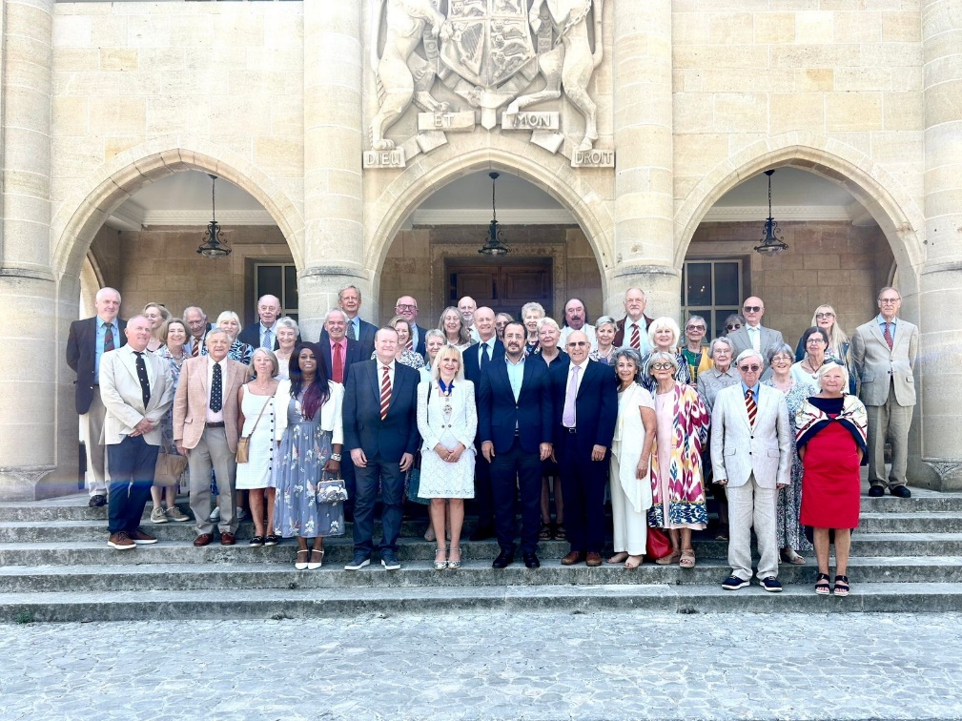

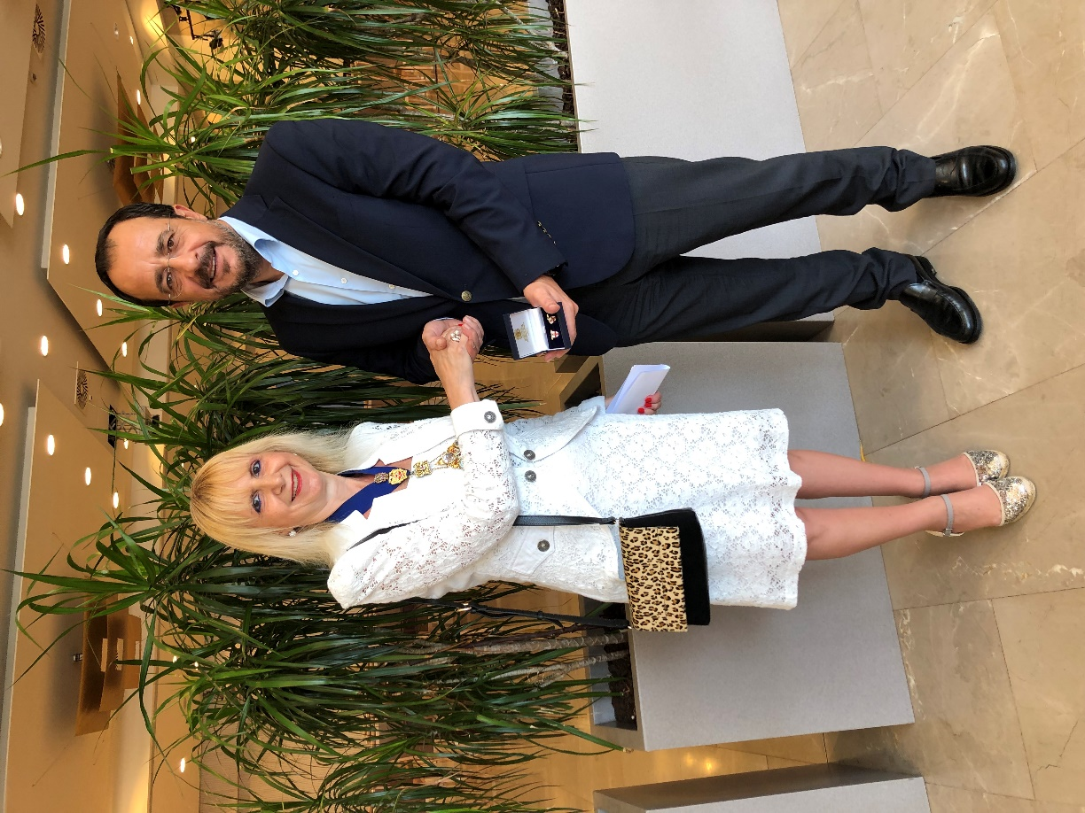

After a long and filling lunch on the border with the Turkish side of the capital we returned to our hotel and several group members took a refreshing dip in the sea before changing for dinner and our Cypriot evening entertainment.

Saturday, we ventured through one the border crossings to visit the Cathedral church of Morphou, built in the 16th century on the remains of a Byzantine church within a monastery. The church is dedicated to St Mamas who rescued a lamb from the mouth of a lion.

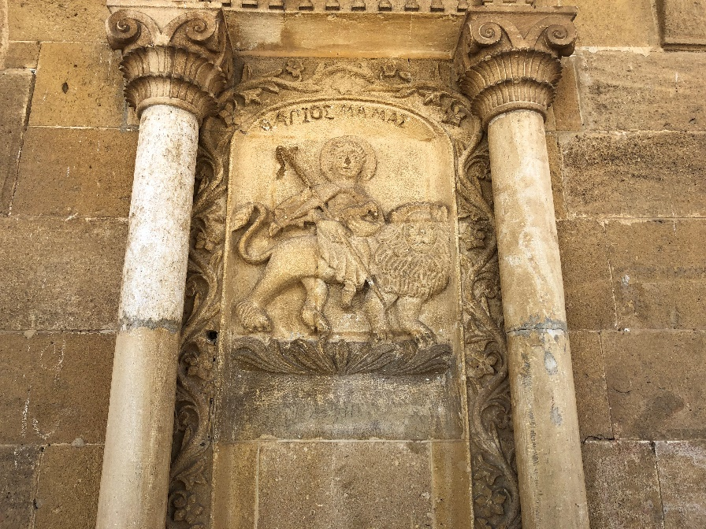

We then proceeded to the ancient site of Soli with an amphitheatre dating back to the 2nd century BC where we were privileged to hear some Shakespeare courtesy of our Senior Warden and see some well-preserved mosaics. Next on the itinerary was a visit to the UNESCO World Heritage church of Panagia Tis Asinou which has some of the best-preserved Byzantine wall paintings in the world, before another sumptuous lunch.

Again, due to the Master’s contacts, we were joined that day by the Mayor of Morphou, who added personal detail to the visits and rescued a couple of members who had forgotten their passports, who we had to leave at the border but were kindly collected by the Mayor and therefore didn’t miss out on either the charming church or lunch!

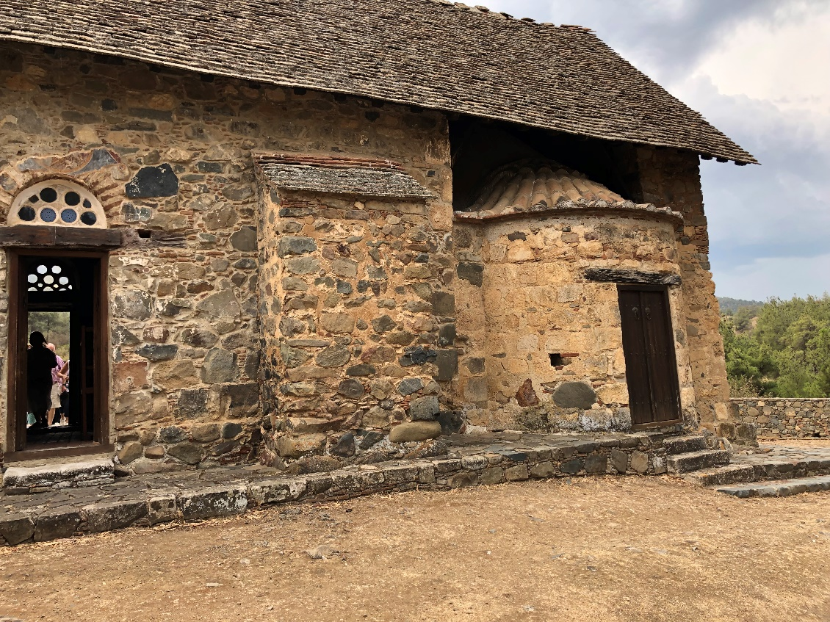

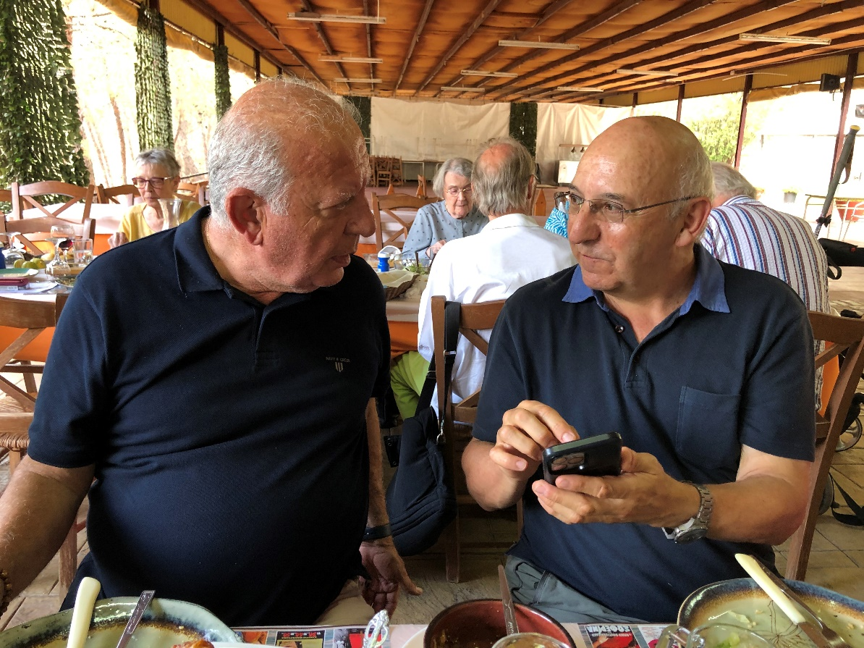

Victor Hadjiavraam, Mayor of Morphou with former Lord Mayor, Sir Michael Bear

Sunday saw the group visit the Troodos mountains, where we visited the church of St Nicholas and the charming, picturesque village of Omodos, before a wine tasting in the famous Krasochoria region.

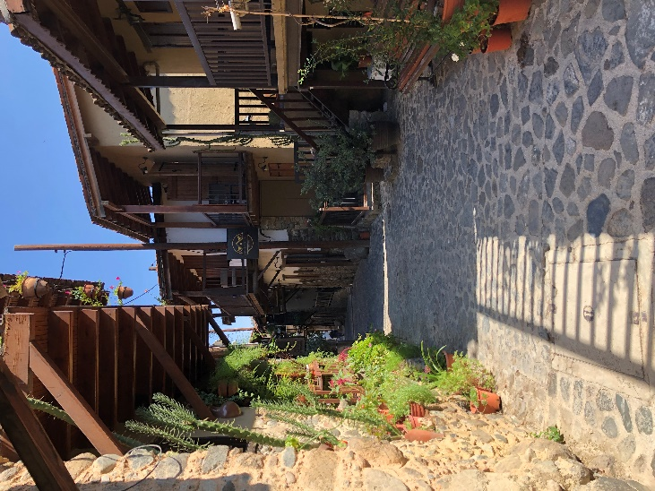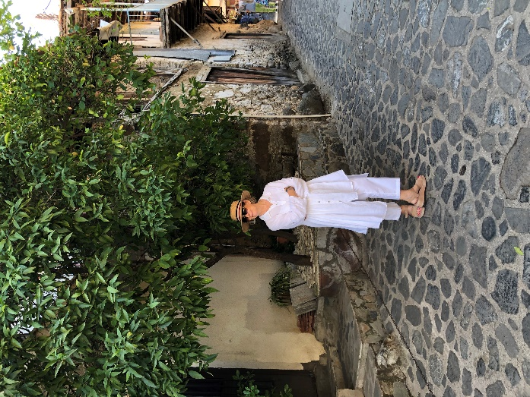

Another lunch passed and what was now the routine ‘pre-dinner swim’ in sea concluded the day.

On Monday, the group headed southwest to the ancient site of Kourion, an enormous kingdom that would take a full day, if not two to visit in full. We focused on the highlights: some mosaics and the Greco Roman theatre built between 200 BC and 200 AD.

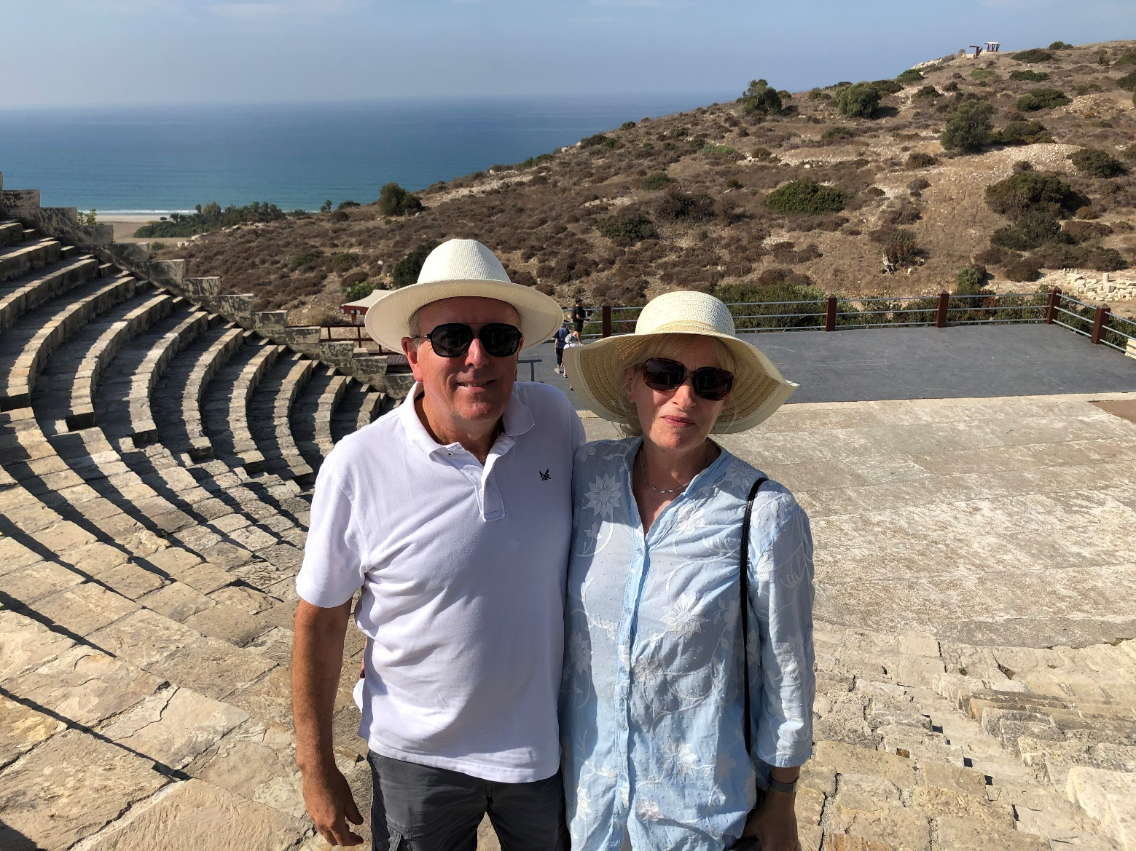

After a brief sojourn and coffee or ice cream overlooking the birthplace of Aphrodite, where she arose from the sea, it was time to see the archaeological pièce de resistance of Kato Paphos. We began in the House of Dionysus (which felt like a sauna) to view its many rooms and fabulous mosaics, before proceeding to the House of Aion.

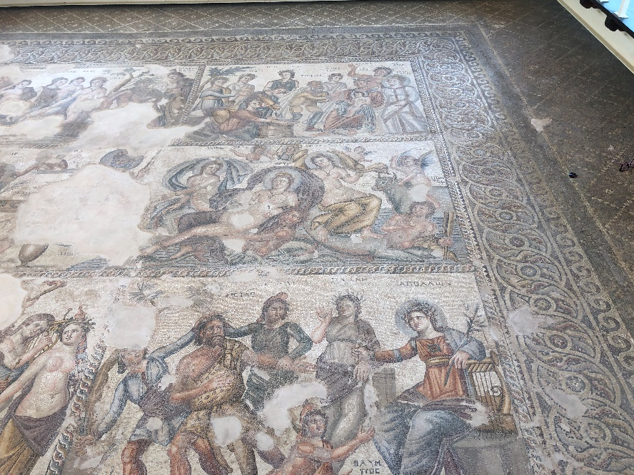

Lunch at the Castle in the port area overlooking the sea completed our archaeological feast and then it was time to taste and see how Loukoumia (aka Turkish/Cypriot delight) is made. The range of flavours was amazing: traditional rose to bergamot and ouzo.

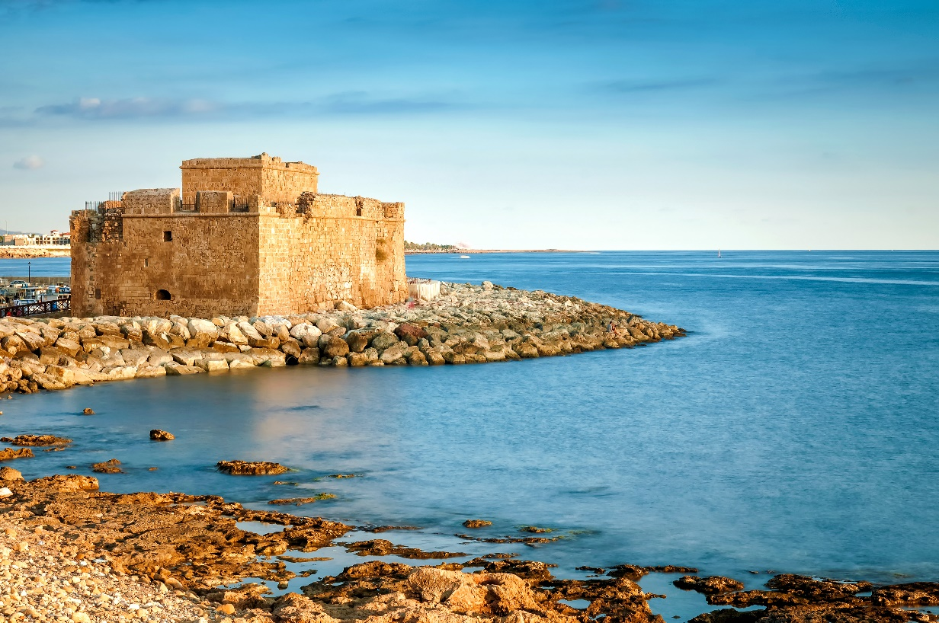

We arrived back at the Hotel in time for a final sea swim before donning our glad rags for the farewell dinner. H.E. Andreas Kakouris, former High commissioner to the UK, now Permanent Secretary to the Minister of Foreign Affairs, and Mayor Victor accompanied by their wives joined the group for a veritable feast of high class dining at the Artima, where the Master thanked them both for their assistance in arranging the trip, with Sir Michael thanking the Master on behalf of all the group for a fabulous and fascinating holiday.

FUTURE EVENTS

https://www.guild-freemen-london.co.uk/events

Time to turn our thinking toward the Annual Banquet at Guildhall, the Guild’s flagship event, which is swiftly approaching, taking place on Friday 6th December. We hope to have the full Civic group joining us, as well as the usual rousing songs from the London Banqueting ensemble. Members travel from near and far to attend the event and it is always a fantastic occasion – the Master also has a couple of extra special surprise entertainments for attendees. If you’ve not already booked, please complete the booking form on the website, or get in touch. If you have booked but not confirmed your guest details, please do let us know as soon as you can. https://www.guild-freemen-london.co.uk/events/home/annual-banquet-6

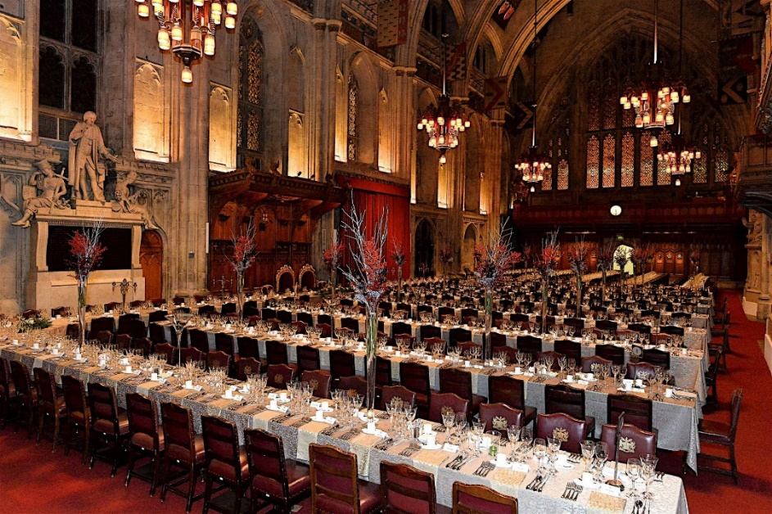

The Guild AGM will take place on Wednesday 16th October at Tallow Chandlers’ Hall. Members who wish to attend need to arrive at Tallow Chandlers’ by 6.15pm as the Meeting will start promptly at 6.30pm. The Champagne Tasting and Supper will follow for those who have booked. If you have not booked for this event yet please do so as soon as possible as we are in the final stages of confirming numbers.

The Lord Mayor’s Show

We are awaiting confirmation of enclosure tickets for the Lord Mayor’s Show and will be in touch with those who have expressed an interest in these as soon as we have news. The Guild, however, are fortunate to be able to offer its members lunch on the day of the Lord Mayor’s Show (Saturday 9th November) in the Members’ Private Dining room which overlooks Guildhall yard. The lunch itself is always a superb three-course meal with wines as well as a cheese board.

https://www.guild-freemen-london.co.uk/events/home/lunch-after-the-lord-mayors-show-6

The College of Arms visit is fully booked but we hope to be able to offer another visit in 2025 for those who have an interest. We have also had to postpone the Virtual Talk about the Charity, which will be rearranged in 2025.

Team and Opium Online Talk

On Monday 18th November Andrew Johnson, Guild Member, Liveryman of the Worshipful Company of Joiners and Ceilers, an experienced international chief executive and a respected keynote speaker will be giving an online talk on the City of London’s role in the trade in tea and opium.

The talk is free of charge but donations to the Guild charity are appreciated.

The Carol Service on Monday 9th December 2024 will now be held at St Mary-Le-Bow, Cheapside, another of Christopher Wren’s Churches, due to the ongoing repairs at St Stephen’s Walbrook.

GUILD NEWS
BEADLE – JOHN HOLLINGSWORTH

Many of you will have experienced the welcome of our longstanding Beadle, John Hollingsworth, at dinner events or even your Joining Ceremonies. After 35 years of service John has decided it is time to lay down his staff and move into retirement. John became a Toastmaster in 1989 after a successful career in the Metropolitan Police, where he spent 28 of those years with Special Branch working in the Close Protection Unit. He became Beadle to the Guild in the same year and has served as Beadle for four other Companies too, including the Worshipful Company of Loriners during the Mastership of the Princess Royal. He has achieved the rare honour of been elected President of the Society of London Toastmasters on 2 occasions.

The Guild are hugely thankful to John for his loyalty and generous service over these years and would like to present John with a gift to reflect this.

If you would like to make a donation towards this gift please make a transfer to the Guild Bank Account, Sort Code: 20-20-14, Account Number: 80183334, marking it with your Surname and GIFTJH. We hope to present this to John at the Annual Banquet on 6th December.

David Clarke: The Master and the Guild were sad to learn of the passing of Guild Member David Clarke last month, having been a member of the Guild since 1996. He will be sadly missed.

Peter Lewis Crown: It is also my sad duty to report that Peter died last month. His obituary was published in The Times on 4th September.

OTHER DATES AND NEWS

Don’t forget about the Lord Mayor’s Knowledge Miles lecture series and his Coffee Colloquies, full details of both can be found at: : Knowledge Miles: The 695th Lord Mayor's Lecture Series - Gresham Society
And Lord Mayor's Coffee Colloquies - City of London

Save the date for 2025, when Adrian Waddingham our Senior Warden will be taking us on a tour of the Southern Lakes: Arrive Sunday 28th September and depart Thursday 2nd October 2025. Adrian is also planning a trip to Norfolk 6th – 8th April. Further details of both trips will be circulated later this month / early October.
Best wishes,
Kate
Kate Pink
Clerk to the Guild of Freemen of the City of London.

