**October Newsletter 2024**

Dear Members,

I hope you are well.

Before we delve into the exciting activities at the Guild over the last month I wanted to remind you that our Beadle John Hollingsworth is retiring after 37 years. If you would like to make a donation towards his leaving gift please make a transfer to the Guild Bank Account by the middle of November, Sort Code: 20-20-14, Account Number: 80183334, marking it with your Surname and GIFTJH. We hope to present this to John at the Annual Banquet on 6th December.

**Speaking of the Banquet, if you have not yet made an application to join the Guild for this special evening, please do so asap and no later than next Friday, in order to guarantee your name in the programme. I am pleased to announce that the Guest speaker is Nigel Wray, investor, entrepreneur and former chairman of Saracens Rugby Club who has a heart for the local community.**

After a successful trip to Cyprus, the Master ended September by taking to the streets of London for the ever-popular Annual Sheep Drive and Livery Fair, arranged by the Worshipful Company of Woolmen. This year the event, taking place on Southwark Bridge, was opened by the British Actor Damian Lewis CBE, alongside the Lord Mayor Michael Mainelli and other City representatives.

The Master with Damian, newly appointed Sheriffs Greg Jones and David Chalk with the Lord Mayor and Guild Assistant Clerk, Abbie

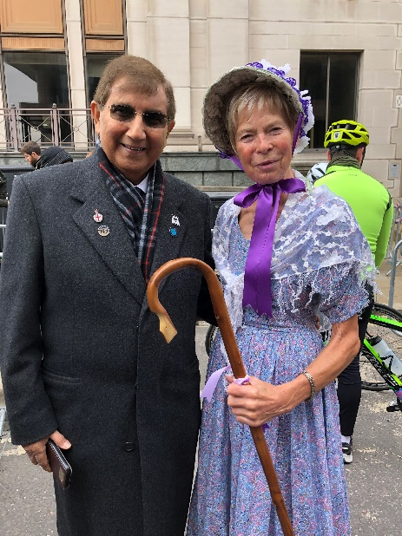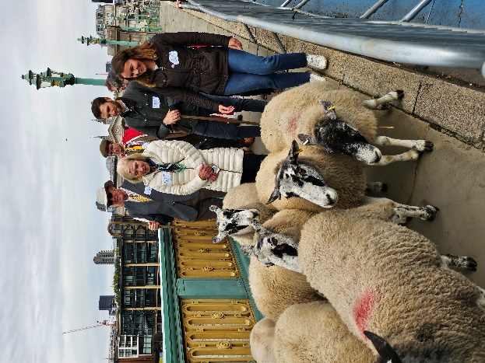The Master drove her sheep across the bridge, and then gave her support to the Guild Members who followed suit. A particular mention for Guild Member Rosemary Dymond who had dressed up as a ‘bo-peep’ and was very popular with the crowd and photographers.

Members driving sheep, Rosemary with the principal sponsor of the day Mr Azad Ayub, who is also a Guild member

The Master spent the rest of the morning enjoying the wares of the Livery Fair, including Whisky from the Isle of Sky, creations from the Leathersellers, Basketmakers, and Bakers, and textiles and yarns from numerous Woolmen, before sitting down to a lovely lunch with members at the Boot and Flogger, the only ‘Free’ pub South of the River, privileged so thanks to owner John Davy being a ‘Free Vintner’.

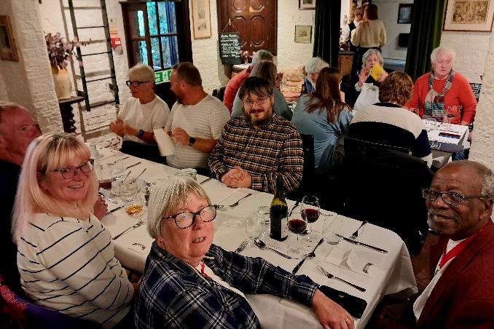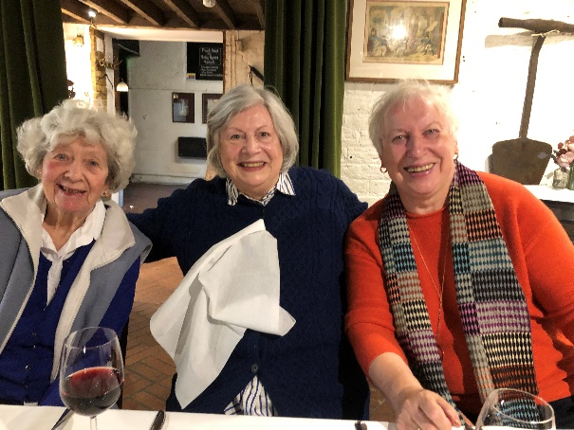

Members at lunch at The Boot and Flogger

October began with another group experiencing a visit to the College of Arms. Former Sherriff and Guild Member Andrew Marsden was present at the visit and the group were able to see his own Coat of Arms, dated 29th July 2011, sparking much discussion about heraldry amongst the group. Once again, the evening was enjoyed by all.

The Master, Lisa Rutter, and her husband Mark represented the Guild as guests at the Trades House of Glasgow Dinner in Glasgow, a charity that’s been part of the city since 1605. The Guild is always happy to strengthen its friendship with the Trades House.

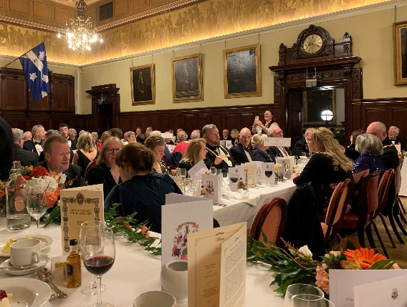

October rounded off with a Court meeting and the AGM at Tallow Chandlers’ Hall, followed by a special Champagne Tasting and supper. Many of the new Freemen guild members were able to join us and hear Chris Scott from Thrifty Fifty introduce us to the heritage of Sparkling Wines, the difference between Proseccos and Champagnes, and offer a chance to try a rather wonderful Chanoine Frères Brut Rosé Champagne NV, an unheard of yet very popular Australian sparkling red from Paulettes Trillians, and an intriguing Cantina Orsogna Malvasia Orange Pet Nat, which very much split opinions! The Master had invited former Mayor of Barnet, David Longstaff, as the speaker for the evening, and he regaled the members of his experience of running the London Marathon and the many challenges, and often surreal moments he encountered; like overtaking a rhino!

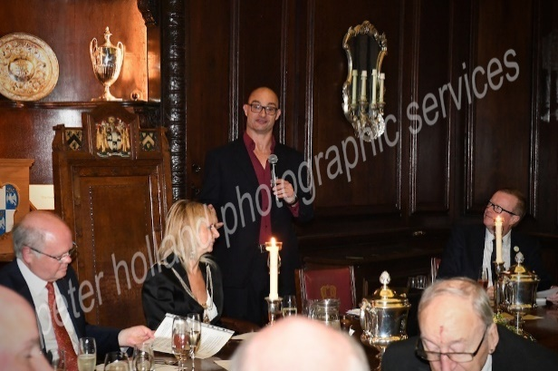

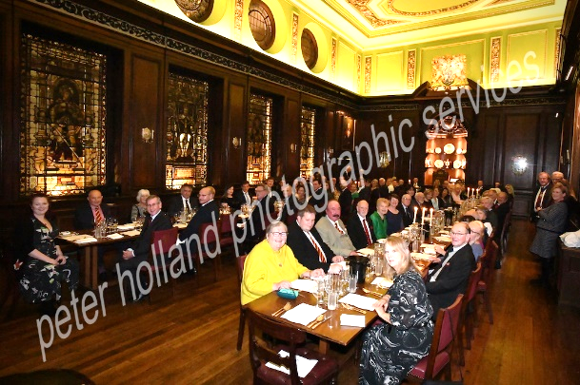

Photos of the Tasting, AGM, and New Members Joining Ceremony can now be viewed on the Website. You will also find photos from the Sheep Drive, and the Lunch at the Boot and Flogger. If you wish to share any of your photos of events with the Guild, do send them to [admin@guild-freemen-london.co.uk](mailto:admin@guild-freemen-london.co.uk) .

**Guild Events**

[**https://www.guild-freemen-london.co.uk/events**](https://www.guild-freemen-london.co.uk/events)

With only a few more events left in the Guild Calendar for 2024, the office has been turning its attention to the **Annual Banquet** at Guildhall on **Friday 6th December** and the delights the Master has in store for the evening. If you are yet to book your places, please do so by Friday 1st November.

<https://www.guild-freemen-london.co.uk/events/home/annual-banquet-6>

Enclosure Tickets for the **Lord Mayor’s Show** and are now sold out. You may still enjoy the Parade from many areas around St Paul’s or Guildhall. **NB:** **there are 4 places available for lunch after the Show in the Private members dining room at Guildhall.**

We are excited to be hearing once again from Guild Member and respected keynote speaker Andrew Johnson at our **Virtual Talk** on the fascinating subject, ‘Tea and Opium’. The talk will take place via zoom **on Monday 18th November 2024** at 6.30pm. Places are readily available, at no cost, although a donation to the Guild is Charity is appreciated.

<https://www.guild-freemen-london.co.uk/events/home/tea-and-opium-a-virtual-talk>

The **Carol Service** on **9th December 2024** will now be held at St Mary-Le-Bow, Cheapside, another of Sir Christopher Wren’s Churches.

The original church dates back to 1080 and was built as part of the Norman Conquest. Known as the church of the Bow Bells it was the first church, after St Paul's Cathedral, to be rebuilt, after it's destruction during the Great Fire of London. It was rebuilt once again after being bombed out during the Blitz.

We do hope you will be able to join us as we enter the Christmas season and share wine and canapes after the service.

<https://www.guild-freemen-london.co.uk/events/home/carol-service-at-st-mary-le-bow>

**City and other news and events**

A message from the Lord Mayor and Lady Mayoress:  
  
‘I hope that you have had a wonderful summer and are keeping warm as the cold days draw in. The Lady Mayoress and I can hardly believe that the year is nearly at an end and with it, our duties as Lord Mayor and Lady Mayoress.  We are very grateful for the all the support we have had throughout the year from all of you and have one final request:

Join us to celebrate the end of our year at the **Grand Finale** where the West End meets Guildhall for **A Night at the Musicals!** Taking place on **Wednesday 6 November** at Guildhall we will be hosting an evening of entertainment and fundraising where you will have a rare chance to experience the Great Hall in one of London’s oldest buildings like never before – with intimate tables and low lighting laid out to evoke a 1920s jazz club cabaret.

The event will be raising money for The Lord Mayor’s Appeal, supporting three inspirational charities – MQ Mental Health Research, Homewards – a Royal Foundation programme and National Numeracy.  They are all delivering groundbreaking programmes to bring solutions to some of the UK’s most pressing societal issues.  
   
On arrival, guests will be served bubbles and canapes before sitting down to enjoy a spectacular whistle stop tour of popular musical classics from Cats to Moulin Rouge performed by musical aficionado and West End star Darren Day and a talented cast from Beyond Repair.

During the performance there will be the opportunity for guests to purchase wine and an interval to ensure guests have a chance to bid on the wonderful silent auction and purchase tickets for the raffle. Tickets to the show only are £250 and include bubbles and canapes.

Those choosing the afterparty dinner package can join the Lady Mayoress and I in the Guildhall’s atmospheric Crypts, to dine on a decadent two course feast with wine. As well as a delicious dinner, guests will enjoy more entertainment and the chance to hob nob with the stars of the show. Tickets £350.

We would be delighted if any member of the Guild of Freemen would consider supporting us by taking tickets.  To make a booking, please complete the online booking form [at Grand Finale 2024](https://www.thelordmayorsappeal.org/news-and-events/events-calendar/1381/grand-finale-2024/) or email [events@thelordmayorsappeal.org](mailto:events@thelordmayorsappeal.org).’

On **Monday 2nd December**, **11am to 8pm** Drapers’ Hall will once again open its doors to the City Christmas Fair. Please join us for a day of luxury Christmas shopping with over 50 fantastic stalls selling everything from festive food to jewellery and from clothing to homewares. [Entrance Tickets — City Christmas Fair](https://www.citychristmasfair.com/tickets?utm_source=City+Christmas+Fair+Audience&utm_campaign=c5cd61b93c-citychristmasfair2022_COPY_01&utm_medium=email&utm_term=0_884c23aa8b-c5cd61b93c-146643647&mc_cid=c5cd61b93c&mc_eid=102c76445f)

**A Thank you from the Sheriffs**

Now that our year in office is in the rear-view mirror, we wanted to thank you all and your members for the fantastic support, friendship and camaraderie which we enjoyed during our year in office. A fruitful year full of memorable events, dinners, lunches and lectures. We were happy to support them all.

Working together, separately, and with the Livery and the team at the Old Bailey, we have sought to make a contribution to our City. We would like to highlight:

* Collectively we have made a material difference to the Sheriffs’ and Recorder’s Fund – raising over £100,000, increasing its annual income by about 50%. A particular contributor was the cycle ride to visit the Sheriff of Nottinghamshire. Thank you to the 14 liverymen and women who made the journey. Another contributor has been the post Old Bailey lunch donations, something introduced this year. Thank you all those who supported these initiatives.
* The portraits of the 15 Judges of the Old Bailey by Jane Masojada which also raised funds for the Sheriffs’ and Recorder’s Fund. These captured the essential humanity and personality of the wonderful Judges who guide our most senior criminal court. A record for the ages. They will be on show at Painter Stainers in November.
* The outreach work of the Old Bailey supported by Gary Langley, seeking by active participation in school visits and events at the Bailey, to reduce the likelihood of young people to get involved in crime.
* The work by both Sheriff’s to create more Routes to Roles in City Firms. Our City is one which welcomes all talents. Sometimes individuals need inspiration or a route map. We hope our work will help more individuals clamber over barriers.

Thank you all for your support. We all look forward to working with you all in the future.

Best wishes

SAVE THE DATES FOR 2025

Please see below some dates for 2025 whilst the Master Elect, Adrian Waddingham works hard on finalising his year.

Thursday 23rd January Installation of the new Master with dinner at Tallow Chandlers’ Hall

Tuesday 28th January Visit to the Great Hall, St Bartholomew’s

Tuesday 11th February Visit to St Brides Print room followed by lunch

Tuesday 25th February Tour of a private collection of Jade

Wednesday 26th March Dinner at Barber Surgeons’ Hall

Friday 28th March United Guilds Service followed by lunch at Pewterers’ Hall

Sunday 6th-Tuesday 8th April Holiday in Norfolk

Thursday 10th April The Lord Mayor’s Big Curry Lunch at Guildhall

Monday 28th April Informal visit to Battersea Power Station and nearby walk

Wednesday 7th May Guided visit of the Frick Museum and lunch

Monday 30th June Black tie dinner at Haberdashers’ Hall

Monday 14th July Royal Holloway visit

Saturday 19th July Cart Marking

Tuesday 29th July Holland Park Opera – La Traviata

Sunday 28th September Sheep Drive and lunch

Sunday 28th September - Holiday in the Southern Lake District

Thursday 2nd October

Monday 27th October Black tie dinner at Trinity House

Saturday 8th November Lord Mayor’s Show followed by lunch at the Guildhall

Friday 5th December The Annual Banquet at Guildhall

Lunch at Mercers’ Hall, a guided tour of the Clock Museum, a celebration of Lancashire day with a quiz and fish n chips, an outing to the Catering College, a visit to Formans’ smokehouse, and more are also planned but dates have yet to be finalised.

As the night’s draw in, many of you may be turning your thoughts to preparations for Christmas (yes, I mentioned it!), and I am pleased to say that we are fully stocked up with Christmas Cards and Crested Envelopes for you to send. Orders can be placed online, £10 for a dozen or £15 for two dozen.

We also have a number of other Guild crested items you may wish to purchase such as Silver or Gilt Metal Cufflinks, Stick Pins, and Brooches. Do take a look at our webshop online or drop a message to me, the Assistant Clerk should you wish to make a purchase.

<https://www.guild-freemen-london.co.uk/shop>

This will be our last newsletter until after the Carol Service. I look forward to seeing those of you that can attend the Banquet at Guildhall, or at the Carol Service.

As always, thank you for your support to the Guild.

Your Truly

*Abbie*

Abbie Jones

Assistant Clerk